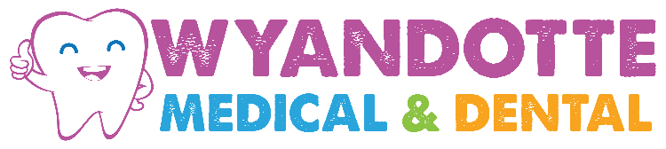

Care of Bonding, Crowns and Veneers:
- Do not chew on hard foods such as candy, ice, meat bones, etc.
Directly on your bonded, crowned, or veneered teeth.
- Be careful not to bite on pens, pencils, etc.
- Do NOT chew your fingernails!!
- Wear a mouth-guard while playing contact sports.
- You should brush and floss your teeth daily (use a soft bristled brush with rounded edges or and electric brush). Proper brushing technique is very important.
- Have your teeth cleaned and checked on a regular basis, proper care will maximize the life expectancy of these restorations.

